
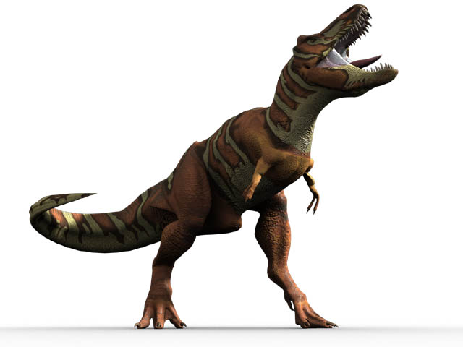
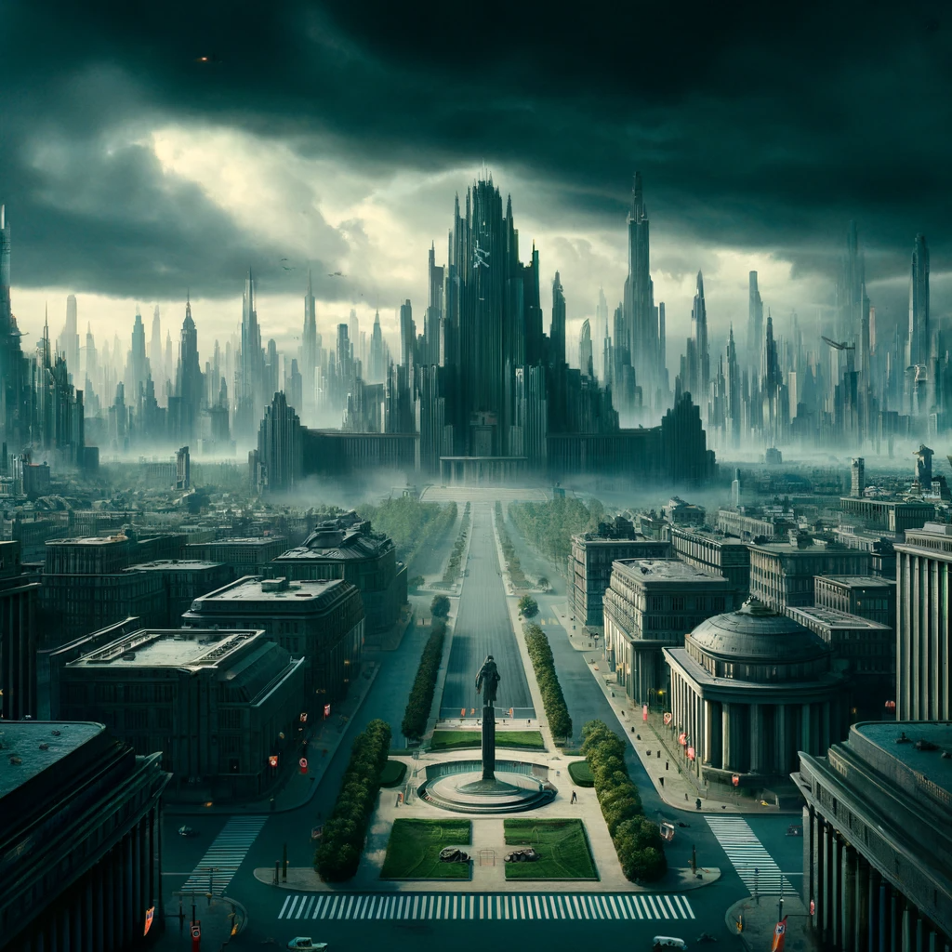
ddd

Vote for President
── ⋆⋅☆⋅⋆ ──
Pay $10000 to Time Safari
── ⋆⋅☆⋅⋆ ──
Attend Mr. Travis’ Safety Training
── ⋆⋅☆⋅⋆ ──
You Forgot to Vote!
Move Back 3 Spaces
Time machine hit by lightning!
Roll Again
Time Glitch!
Go Back to Start

Move Back 1 Space

Lose a Turn

Move Back 2 Spaces

Move Forward 2 Spaces

Lose a Turn

Roll Again

Lose a Turn
Move Back 2 Spaces

Go Back to Start

Lose a Turn

Move Back 2 Spaces

Move Forward 2 Spaces

Lose a Turn

Move Back 2 Spaces

Lose a Turn

Start



Finish

